TRAINING

Training - one of new features in GMC-simulator. it is very similar to management budget and affects same productional and financial performance of the company, but less powerfull. Impact of training can be summarized in 3 areas:

1．Market changes.

2．Broken parts.

3．Absence / sickness assembly workers.

**Market - Test 1**

Training increases sales of your products, but has strong decreasing effect (it means that every extra point of training will make less sales than previous). Influence is the same for all products and markets, maximum market increasing is about 5-6%. Training also has cumulative effect from training investments in previous periods. In the graph you can see test results from several control groups. Vertical - relative change in sales compared with the previous period, horizontal - absolute value of training.

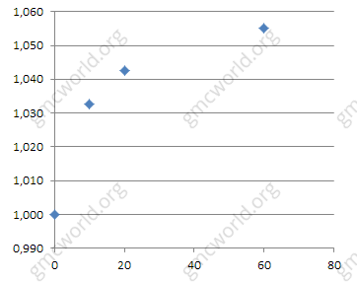

**Market - Test 2**

Competitors slightly effect on sales. Similar graph with test results, but with smaller range of training values.

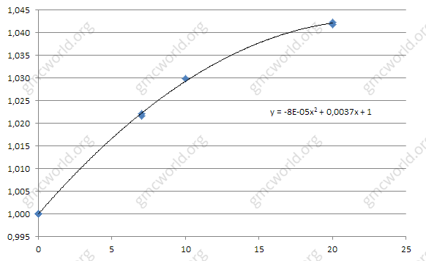

Similar to administrative budget, training has only ⅔ of full effect in 1 period and full effect on sales in 2 period.

To save effect of training from investments in previous periods for the next period (for example in 5 period to save money) - it will be enough to put ½ of past investments. For example, typical strategy of using training can be 40 - 40 - 40 - 40 - 20.

**Broken parts**

Effect acts equal on all products, maximum reduction of broken parts can be reached at 0.3%. Broken parts also has cumulative effect from investments in previous periods. Vertical - absolute value of broken parts. Horizontal - absolute value of training.

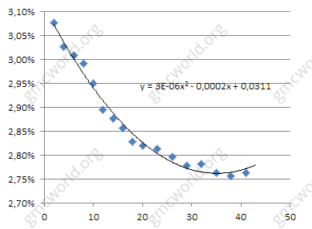

**Absence / sickness assembly workers**

All the same as for broken parts. Training reduces absence or sickness assembly workers, which reduces load of assembly workers, (effect is decreasing). Vertical - absolute value of absence / sickness. Horizontal - the absolute value of the training.

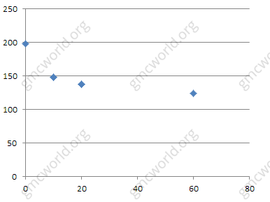

**Hints**

1．1 period - ⅔ effect, 2 period - full effect

2．Strong residual effect

3．Dependence is decreasing

4．Effect is equal for all markets and products.

培训

1．Market changes.

2．Broken parts.

3．Absence / sickness assembly workers.

培训 - GMC模拟器的新功能之一。它与管理预算非常相似，影响到公司的同样的生产和财务业绩，但效率较低。培训的影响可以归纳为3个方面：

1．市场变化。

2．废品部分。

2．缺席/病假组装工人。

**市场－测试1**

培训增加了您的产品销售，但效果却很强（这意味着每一个额外的培训点都会比以前减少销售量）。 所有产品和市场的影响是相同的，最大市场增长约为5-6％。 培训也具有以往培训投资的累积效应。在图表中，您可以看到来自几个控制组的测试结果。 垂直－销售量相对于上一期间的相对变化，水平－绝对值的培训。



**市场－测试2**

竞争对手略有影响销售。与测试结果相似，但训练值范围较小。



类似于行政预算，培训在第1期只有全面的效果的2/3，第二期时销售作用全面发挥作用。

为了节省下一期（以5个时期节省资金）以前期间的投资培训的效果，只需投入一半的投资。 例如，使用培训的典型策略可以是40 - 40 - 40 - 40 - 20。

**废品部分**

所有产品的效果相当，破碎部件的最大减量可达到0.3％。 零部件也有前几期投资的累积效应。 垂直 - 断裂部件的绝对值。 水平 - 训练的绝对价值。



**缺席/病假组装工人**

与破碎零件一样。 培训减少组装工人的缺勤或疾病，减少组装工人的负担（效果正在减弱）。 垂直 - 缺勤/绝对值。 水平 - 训练的绝对值。



**提示**

1．第一期有2/3的效果，第二期有全部的效果。

2．很强的残留效应

3．依赖性是下降的

4．对所有市场和产品的效果相同